COAL-LAB PROJECT REPORT

PROJECT NAME: ATARI BREAKOUT GAME

GROUP MEMBERS: Muhammad Affan Khan P19-0045
Attay Rasool P18-0046
Zohra Sardar P19-0039

ABOUT THE PROJECT: In our project we have a game named Breakout .It is arcade developed game and published by Atari and released on May 13, 1976.
Breakout begins with four rows of bricks, with each row a different color. The color order from the bottom up is Purple, blue, yellow and red. Using a single ball, the player must knock down as many bricks as possible by using the walls and/or the paddle below to ricochet the ball against the bricks and eliminate them. If the player's paddle misses the ball's rebound, they will lose a turn. The player has three turns to try to clearbricks. Each brick earns same number of point which is 1. The paddle shrinks to one-half its size after the ball has broken through the red row and hit the upper wall. Ball speed increases at specific intervals: after four hits, after twelve hits, and after making contact with the orange and red rows.

GAME MECHANISTIC: For Breakout the 64 KB of main memory are logically separated into different sections, as you can see above.

- The boot loader does some initialization that is done only once, like drawing the white walls, then it jumps over the global variable storage to the start of the main loop.
- The global variables section stores values such as the x-coordinate of the paddle, or the user's score.
- The main loop handles input and drawing and moving around game components, and is run 60 times per second. At the end of the main loop, it waits until the full 16 milliseconds is up for the current frame and then jumps back to the beginning of the loop.
- The functions section contains code for such things as moving the paddle, checking for collision, destroying bricks, etc. The main loop switches control to these functions, which switch control back to the main loop when they are finished.
- The stack stores the values of any non-global variables that will not fit in the 16 general purpose registers. Most programs need to keep track of more than 16 values, so they use the stack. The stack grows down, away from the instructions so that it doesn't overwrite them.
- For Breakout, most of the memory is unused. The binary file is only 3,588 bytes as of this writing and it uses very few bytes for the stack

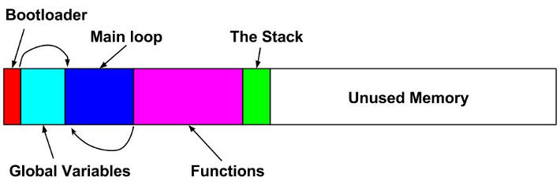

GAME PLAY: The player starts with the ball on their paddle and they can move the paddle left and right. Once the player hits the space bar, the ball is released in a random direction, all of the bricks are regenerated, and the player's score goes back to zero. The ball bounces off of the walls, bricks, and the paddle. When the ball bounces off of the paddle, it bounces more to the left if it hits the paddle on the left side and more to the right if it hits the paddle on the right side, which allows a skilled player to aim. If the ball gets past the paddle the game is over.. The ball speeds up once you hit the first orange brick and then again once you hit the first blue brick. If you manage to get all of the bricks, none more will be generated but you will have achieved the maximum score of 47 points.

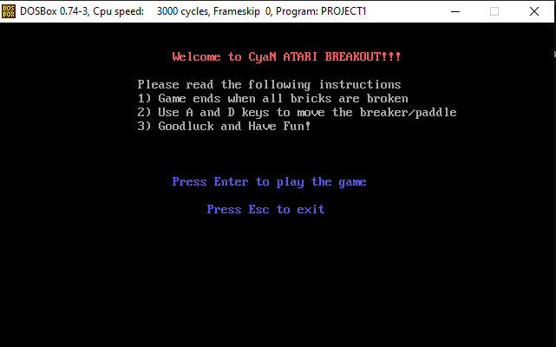

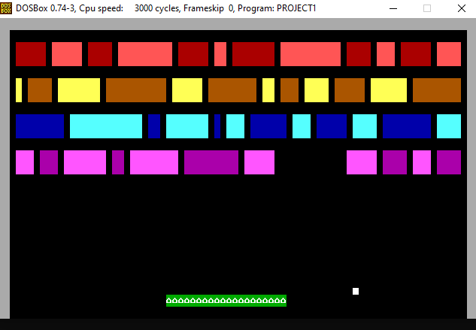

FUNCTIONS MADE:

Clrscr:
The function to clear the dosbox screen and open the console so that it displays the
welcome screen of game.

Printscreen:
Displays all the messages on the welcome screen, if we don’t use this function, it will show us a black screen without any display.

Nextchar:
It loads the characters and changes the display stepwise (welcome screen, game screen) by loading the characters.
Printnum:
Print the number and the console screen which shows the score.

Nextdigit:
It loads the exact display and digits on the display (the correct score)

Nextpos:
It prints the score digits. If I miss this function it displays the same screen except score digits.

Delay:
It produces a delay in speed of the ball, in the beep sound and in the speed of the paddle.

Beep:
It produces a beep sound whenever this function is called e.g. when ball hits the bricks.

Border:
The border function keeps the ball within the borders and reflects/bounces back the ball hits the border.

Clear bricks:
As the ball touches the bricks, the bricks get disappear and the ball bounces back.

Breaker:
This function consist of making the paddle/breaker through which the ball is able to bounce back after the collision.

Ball:
This function consists of the code of formation of the ball after which the game runs.

Welcome:
This function consists of the code to move the paddle to left and right and run the game successfully.

Playloop:
It allows the game to run on console with all the phases. As all of other functions are called in this function.

Fun:
It allows us to run the game phase on the console (move from welcome phase to the game phase).

